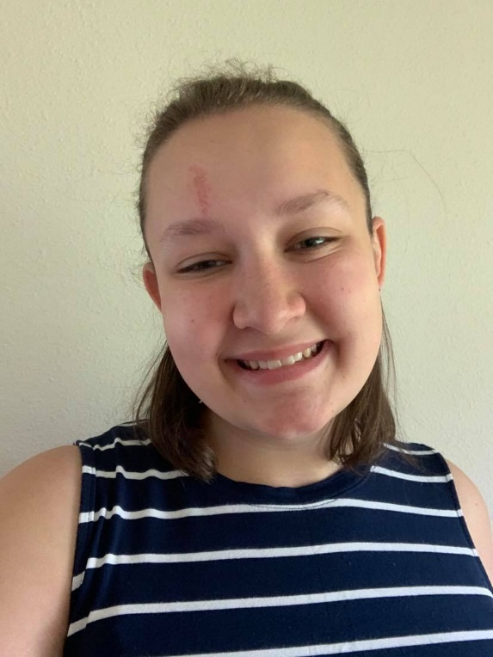
Tarra
Maddox

Describe your plans for next year. I am planning on going to The U in the fall. If all things work out, I’m going to be a paraprofessional at Emerson. I am already traveling being as I’m in Idaho right now but this year Kayla and I are going to Arizona to visit some friends and I want to go to Canada over a break and spend some time on the farm with my family.
Describe a SLCSE-ism that you came to love or has become part of you (willingly or not) while at SLCSE. One thing I always think of is take healthy risks. I try my hardest to always take risks but sometimes I get scared and don’t. Like for example, yesterday Kayla and I went outside and there was a snake on her grandpas drive way and I wanted to pick it up knowing it’s a garden snake but I got scared because I don’t like snakes that much but I next time I will for sure pick it up.
Write an Impact Statement-Teacher Impact Statement. One teacher that has really inspired me is Ms. Brady. I have had her as a teacher probably the longest than every other teacher at SLCSE. She is always someone I talk to when I have a bad day. Whenever we talk, I get a really good and happy feeling. My favorite thing I’ve experienced with her is when she first met my dog, that is when I knew she would be one of my ABSOLUTE favorite teachers I would ever have.

