Salt Lake Center for Science Education
1400 W. Goodwin Avenue, SLC
School Community Council
Agenda: January 13, 2021, 5:00 pm
http://slcse.weebly.com/scc-agendas.html
Welcome and Introductions
Christy Porucznik, Meadow Wilde, Bonnie Starr, Ashley Paulsen, Dora Diana, Lynn Lonardo, Tiffany Rousculp, Jill Drown, Amy Jordan, Richard Scott, Christy Sapp, Niki Hack, Britnie Powell
Meeting Dates and Times
- 2nd Wednesday of every month from now on from 5:00-6:00
  - February 10, 2021
  - March 10, 2021
  - April 14, 2021
  - May 12, 2021
Approve January Minutes
Motion to approve. Seconded.
Re-Opening Plan for Secondary Schools
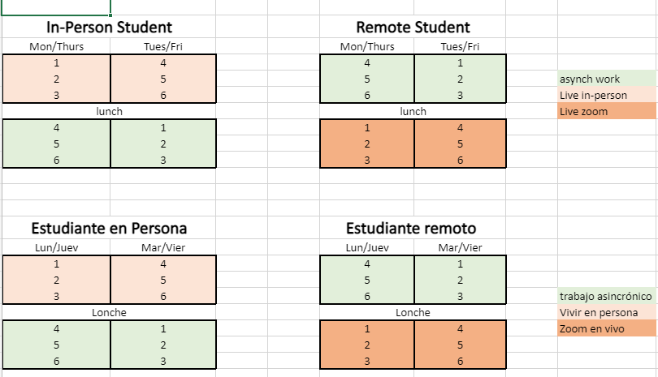
Why was remote, synchronous learning scheduled for afternoons? The logistics of transportation and food services require that in-person learning be scheduled in the morning.
Is there a possibility for SLCSE to maintain the current schedule through the remainder of the school year? Britnie will explore this possibility. If we did this, are families who aren’t represented on SCC getting what they need?
What is the academic failure rate of SLCSE students? There was discussion around the nature of the media implications of remote learning resulting in excessive failure. There has been minimal coverage of information regarding failure rates of other districts and the impact of the inconsistency of switching from in-person to remote due to COVID cases. There has also been a lack of coverage regarding the assets students are gaining during this time: a hugely reduced digital gap (increased internet and device access), increased technology skills, use of Canvas, ability to communicate, etc.
Open House
Planning a virtual event- tour and Q&A panel.
Board Check-in
Board representative not present.
School Fees 2021-2022
http://slcse.weebly.com/school-community-council.html
Motion to approve the 2021-2022 Fees Schedule
- Roll Call Vote:
- Jill Drown- Y
- Lynn Lonardo- Y
- Britnie Powell- Y
- Niki Hack- Y
- Amy Jordan- Y
- Dora Diana- Y
- Bonnie Starr- Y
- Christy Sapp- Y
- Ashley Paulsen- Y
- Christy Poruznik-Y
- Meadow Wilde- Y
Overnight Trips 2020-2022
http://slcse.weebly.com/school-community-council.html
- Feedback/Questions?
Safe Technology and Digital Citizenship Requirements
- Family Resource
Issues of Interest
- Yearbook plan- we have a teacher who is supervising, paraprofessionals dedicated to supporting it. Still working on specific picture gathering plans. If you all have ideas, maybe you’ve seen things that you think could work, we’d be happy to hear.
It was suggested that we encourage parents and students to submit pictures for the yearbook. There could be grade level themed photos (Cats of SLCSE).
- SLCSE Mascot was discussed. Ashley will work with interested students to come up with a plan for identifying a mascot for SLCSE. This will be a student driven project.
Updates from Admin/Upcoming Events
- Superintendent Search Forums- most have concluded, SPED is this evening. But if you have additional feedback you are always invited to contact your board member. SLCSE’s is Joel Organista. joel-lehi.organista@slcschools.org
- Picture Makeup Day Jan 27
- Board Meeting on Tuesday- More on the Reopening Plan for Secondary
To promote ethical behavior and civil discourse each council member shall:
- Attend council meetings on time and prepared
- Make decisions with the needs of students as the main objective
- Listen to and value diverse opinions
- Be sure the opinions of those you represent are included in discussions
- Expect accountability and be prepared to be accountable
- Act with integrity
Land Trust Goal~ Literacy

