**OLIVIA SLAUGHTER**

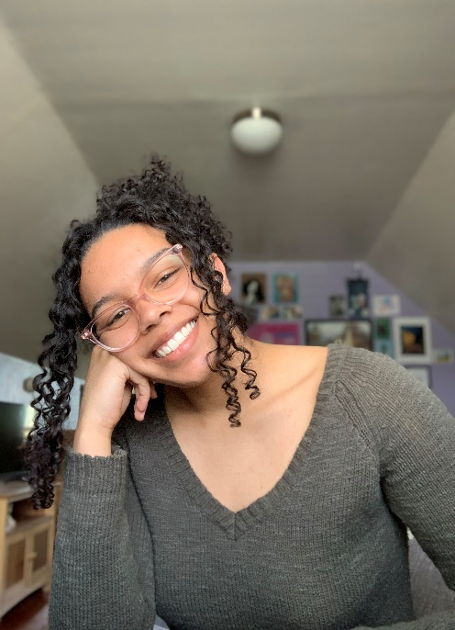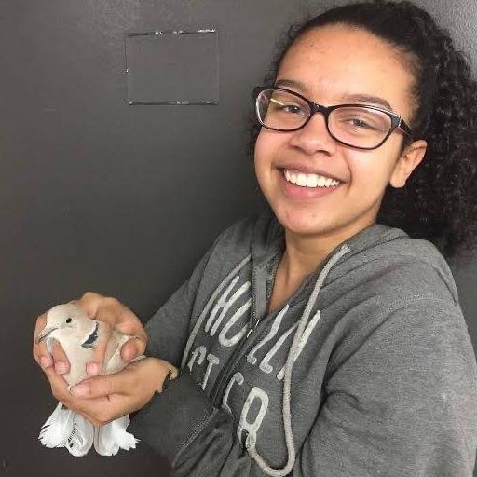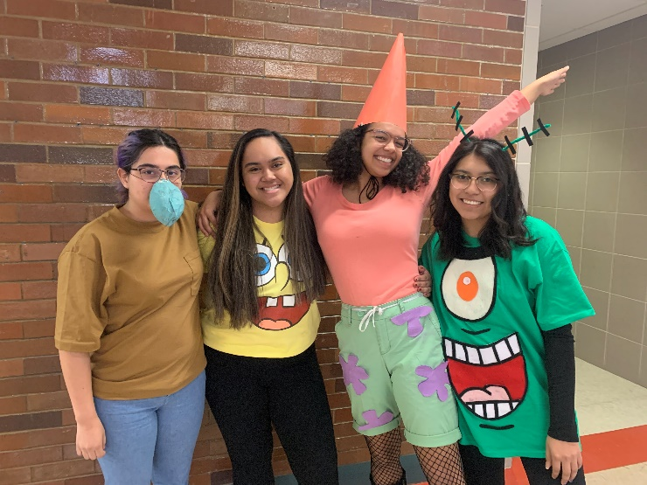**SLCSE Class of 2020**

**A teacher that has had an impact on me…** is Mr. Crandall. He has always emphasized the importance of taking control of our education and doing so by speaking up. Honestly, I initially had a hard time even finding things to say or the words to say it with, but with his encouraging push, I found myself more confident, adding my voice and opinions to his class and many others as I grew older. He truly taught me something I will hold close to me for a lifetime.

**Weirdly…** birds have been a big part of my SLCSE experience? And now I am constantly fascinated by them, which I credit to SLCSE. I spent my first 3 years of high school studying bird lice, venturing to U’s “bird basement,” and hanging out with a bird lice expert in the lab, so that was a big part of it. But I’ve also gone bird banding *so* many times and held countless numbers of birds. A weird takeaway for sure, but I’m so thankful for all of these bird-related opportunities.

**A student that has had an impact on me**… is Ronan. I find her passion for activism and change always inspiring and think she is exactly the type of person our generation needs. I look up to her in these aspects as she has inspired me to stay involved in my community. Not only this, though, because she is always pushing herself academically and her dedication really shows. I aspire to be more like Ronan.

**My favorite SLCSE-ism…** is “Take Healthy Risks” because I feel like it’s always something we need to remind ourselves once we get too comfortable. That phrase pushed me when it came to opening up and sharing my creative work, as it is something I easily get self-conscious about. This SLCSE-ism will be especially important to me as I transition to “real life” (yikes, scary), but I think having those 3 words ingrained in the back of my mind will help defeat that fear.

Not a single Halloween went by that I didn’t go big with my costume (pic from senior year)

**Next school year…** I will be heading to New York to attend Barnard College of Columbia University (if the pandemic allows, of course). During my time there, I’m planning to major in Molecular Biology and minor in English. I could not be more excited for this next venture and to explore NYC culture!

**A fun SLCSE memory I have…** is the time during my sophomore year that language arts classes went to see Hamilton. I remember being so blown away by the musical—I laughed, I cried, and felt everything in between—and afterwards going into an obsessive phase of listening to Hamilton songs, re-experiencing those emotions. I still love it, and would leap at the chance to see it again.