Myra Benedict
Graduating Class of 2020

My Plans for next year

Starting this fall I will be attending SLCC and working in the lunchroom at SLCSE. So, you won’t be seeing the end of me yet! At SLCC I will be majoring in Illustration working towards becoming a Visual Developer. I am also excited to join the Improv club at SLCC
so I can continue my theatrical pursuits.

My Favorite SLCSE-ism
I love the SLCSE-ism “Fail Forward” because every time I make a mistake I just reflect, shake it off, and move forward. Thomas Edison once said, "I have not failed I've just found 10,000 ways that won't work." and this kind of mindset is what I think SLCSE really represents.
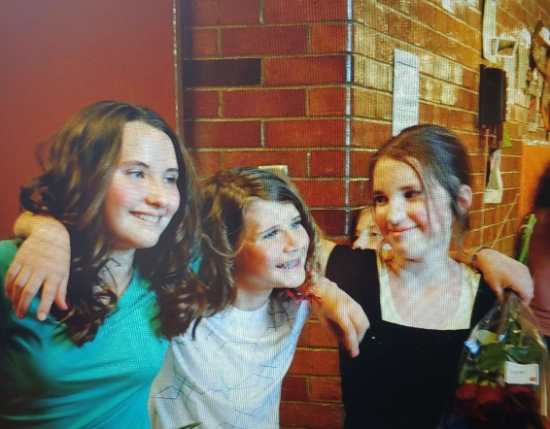
Impact Statement: Bella
Bella Lonardo has been with me through the entirety of my SLCSE experience from 6th grade through graduation. Through all these years she has helped push me to meet my full potential. She was always there for me, backing me up and inspiring me. If the eternally busy Bella was doing homework before class started, that meant I could too. But she helped me in other ways too. Because of Bella I tried many new things that scared me from trying new foods to going on roller coasters at Lagoon. My life would not have been the same without her.
Bella, Riley, and Me right after we performed in the 6th grade play Romeo and Juliet.

SLCSE Memories
There are so many SLCSE stories that come to mind when I look back on the last 7 years but here is one of my favorites...
Okay, so this is from like 7th grade, but I love it. It was during Mesa Verde and we were on a tour. I was in the very front listening to the tour guide when he asked a question "What did the Anasazi people do when they ran out of food storage?" I raised my hand and said loudly with all the surety and conviction a twelve year old could muster, ”CANNIBALISM!"
He then responded with fear and concern in his voice "What? No! You’re MORBID!"
The correct answer was apparently farming.

