SLCSE’s 6th Annual 7th Grade Mesa Verde Adventure

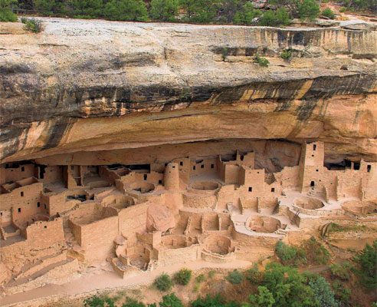

All SLCSE 7th graders are invited to attend SLCSE’s 6th trip to the Four Corners area. This trip will support Utah Studies curriculum through in-depth study of the Ancestral Puebloans. During this 4 day trip, students will go on driving and hiking explorations of Ancestral Puebloan ruins, including cliff dwellings, rock art, pottery, and other cultural art. For more details see the trip (tentative) itinerary on the back.

When: Wednesday, May 13 – Saturday, May 16, 2015
Where: Mesa Verde National Park & Hovenweep National Monument
Who: SLCSE 7th graders
Cost: $140 per student

Students will miss 3 days of school, and will be responsible to make up any missed work.

Financial Aid is available to students that cannot cover the $140. Do not let the cost of the trip stop you from applying if you are interested. With that said, sponsors would also be greatly appreciated.

Students must apply by Tuesday, Jan. 20. Applications, with parent signature, should be turned in to Mrs. Haakenson.

Please note that our mandatory parent and student meeting for the trip will be held on
Tuesday, March 10th from 5:30pm-6:30pm.

We are looking for a few (2-4) parent chaperones to join our adventure. Parents can indicate their interest on the attached form.

Purpose:
This trip is designed to bring history to life. Students will have the opportunity to explore firsthand the remains of the Anasazi, who they studied during their Utah Studies course. Through hiking and camping students will experience a similar environment and lifestyle to that of the Anasazi. Writing and reflection exercises will heighten their awareness of this primitive people’s accomplishments and amazing culture.

Trip Itinerary:
Location: Mesa Verde National Park, Mesa Verde, Colorado
Hovenweep National Monument, Cortez, Colorado
Bluff, Utah
Timeline /Schedule:
Leave 7:30 am, Wednesday, May 13, 2015
Arrive in Blanding Utah around noon. Eat lunch, Tour the Edge of the Cedars Museum, Travel to Hovenweep National Park, Set up camp, Journal Reflections, Dinner, Retire.
Thursday, May 14, 2015
Pack up campsite, Tour Hoovenweep National Monument, Eat lunch, Journal reflections, Drive to Cortez, Set up campsite, Dinner, Star Party, Retire.
Friday, May 15, 2015
Sunrise hike, Tour Mesa Verde National Park (Spruce Tree House & Balcony House), Journal Reflections, Dinner, Retire.
Saturday, May 16, 2015
Break camp, Travel back to Salt Lake City, Arrive by 5:00pm.

2015 Mesa Verde Trip Application
Due to Mrs. Haakenson by Tuesday, January 20

- Why do you want to attend the Mesa Verde trip?

- What do you hope to see/ do/ learn on this trip?

- How is this opportunity important to you?

- In what ways will you positively contribute to this trip?

- In what ways will this trip be a challenge for you?

- Anything else you would like to tell us about your desire to attend this trip?

---------------------------------------------------------------------------------------------------------------------------------------Student’s Name ___________________________________
Parent’s Name(s) __________________________________ Contact Info _________________________
__________________________________ _________________________
In need of financial assistance Yes No
Interested in sponsoring a student Yes No
Interested in being chaperone Yes No
Parent Signature _________________________________ Student Signature ___________________________

**This is not a trip permission slip. Application does not guarantee your acceptance and attendance.**

