Katie Robbins
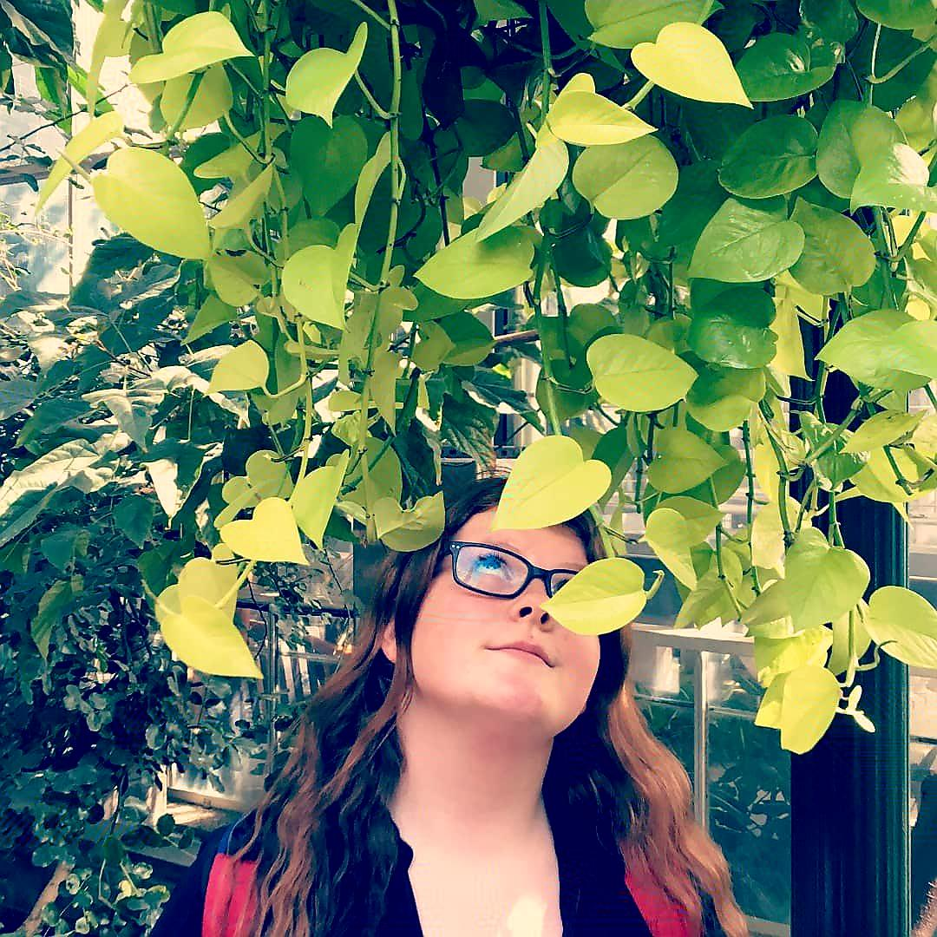

My Plans For The Future
Next year I will be starting at SLCC in the fall. I will be getting my associates in history there, and once I graduate I will then be moving to Washington. There I will get my bachelors in secondary education. I have been offered a management position at my current job, and by October I will be the youngest manager on the team.

SLCSE-ism: Change Reality
Change Reality has been a SLCSE-ism that has always stuck with me since I first started attending SLCSE in seventh grade. “Change reality” really sparked something in me because I always knew that I wanted to help others in the world and in my future, but it took me a long time to officially figure out what that was. And SLCSE definitely put me on the right path.

Impact Statement: The SLCSE Village
At SLCSE I had my own personal village of teachers who were always there for me. At SLCSE I was able to grow into the person that I am, and I have to thank all of the teachers who were there to help me along the way. Thank you all very much for pushing me to be my best and to believe in myself. Ms. Haakenson was able to show me my true passion of teaching and how to be one of the best. Ms. Brady, was always there for me during my rough patches cheering me on. Mr. Crandall helped me fall even more in love with history than I already was. Ms. Armstrong’s door was always open to me, even if I just wanted to draw on her white board. And Mr. Karl, who was never even officially one of my teachers, but who still became very important to me. Without the help of all of these teachers, I wouldn’t be who I am today.
Education is an act of rebellion -Vivian Shell

