SLCSE’s Annual 11th Grade Washington D.C. Adventure

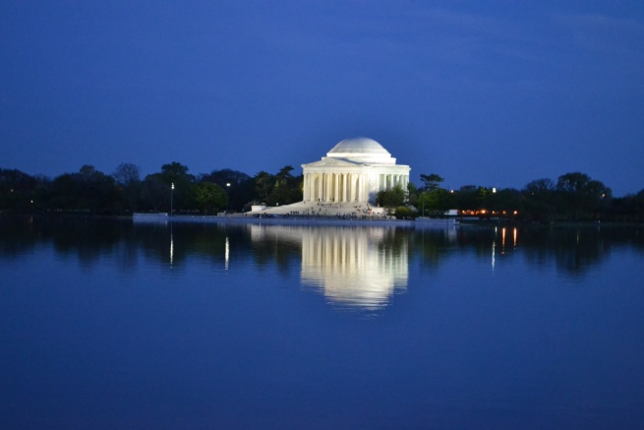
(Mr. Laarman took this picture!!)

Don’t miss out on this exciting opportunity for next year! All SLCSE 10th graders are invited to attend SLCSE’s annual trip to Washington D.C. This trip will further student learning of core social studies curriculum including U.S.Government, U.S. History, Geography, World Civilizations and Financial Literacy. During this 6 day trip, students will explore our nation’s capital, museums, monuments, and historic sites. Students will be actively involved in the planning, fundraising, and execution of this great adventure.

When: Tentatively set for Spring Break 2017 (Thursday, April 6-Monday, April 10)
Where: Washington D.C.
Who: SLCSE 11th graders (2015-16 school year)
Cost: $800 (actual cost is $1250, we will fundraise the difference) – this is broken into 5 payments starting with a $300 non-refundable deposit on September 15, 2016. A few partial scholarships are available for those students who would like to attend but are unable to pay the full cost. Do not let the cost of the trip stop you from applying if you are interested. We want all students to go that want to go!!

What is required to attend?
- Complete trip application with parent signature – turn in to Mrs. Haakenson Friday, May 13.
- Attend mandatory D.C. trip orientation meeting Tuesday, May 31 from 5:15-6:15pm (this is for students & parents)
- Attend 7 out of 8 monthly student planning meetings (this may be replaced with DC related class)
- Contribute a minimum of 40 hours towards fundraising & preparation
- Pay the full amount, either in one lump sum, or according to the payment schedule. The payment schedule will be explained at the mandatory D.C. trip orientation. Students receiving partial scholarship may not be required to meet this requirement.
- You!! Bring your enthusiasm, dedication and willingness to learn and work hard.

2017 Washington D.C. Trip Application
Due to Mrs. Haakenson by Friday, May 13

- Why do you want to attend the Washington D.C. trip? How is this an opportunity for you?

- What do you hope to see/ do/ learn on this trip?

- Propose one fundraiser we could do next year (this can be a generic idea, or it can be a detailed plan).

- In what ways will you positively contribute to this trip?

- In what ways will this trip be a challenge for you?

- Anything else you would like to tell us about your desire to attend this trip?

Name of student interested in going on the trip ____________________________________________________

Parent’s Name(s) __________________________________Contact Info ______________________________

__________________________________ ______________________________ email preferred

In need of a partial scholarship Yes No

Interested in sponsoring a student Yes No Partial $__________________________

Have you taken Financial Literacy Yes No

Parent Signature _________________________________ Student Signature ___________________________

**This is not a trip permission slip. Application does not guarantee your acceptance and attendance.**

